

**Global Heritage Alliance Ends 2023 With High Level End-Of-Year Policy Meetings**

For Immediate Release Contact: Elias Gerasoulis January 25, 2024 No. 1

**Washington, DC—**The Global Heritage Alliance (GHA) conducted several high-level Congressional meetings during December, 2023. Global Heritage Alliance Executive Director Elias Gerasoulis met with the following members of Congress: Congressman Chris Smith (R-NJ), senior member of the House Foreign Affairs Committee, Congressman Ronny Jackson (R-TX), member of the House Foreign Affairs Committee, and Congressman John Carter (R-TX), member of the House Appropriations Committee.

During the meetings, GHA Executive Director Gerasoulis discussed the multi-faceted concerns of its constituencies. GHA lobbyist Marc Lubin (DLM Group) and legal counsel Peter Tompa accompanied Executive Director Gerasoulis in the meetings.

According to GHA Executive Director Gerasoulis “I want to thank Representatives Smith, Jackson, and Carter for their interest in GHA. We look forward to working together on many areas of mutual interest.”

“I appreciate invaluable assistance of Messrs. Lubin and Tompa in our public policy outreach.”

For additional information, please contact Elias Gerasoulis at egerasoulis@global-heritage.org. For general information on GHA, see our Web site at https://global-heritage.org/.

**Photos From Meetings**

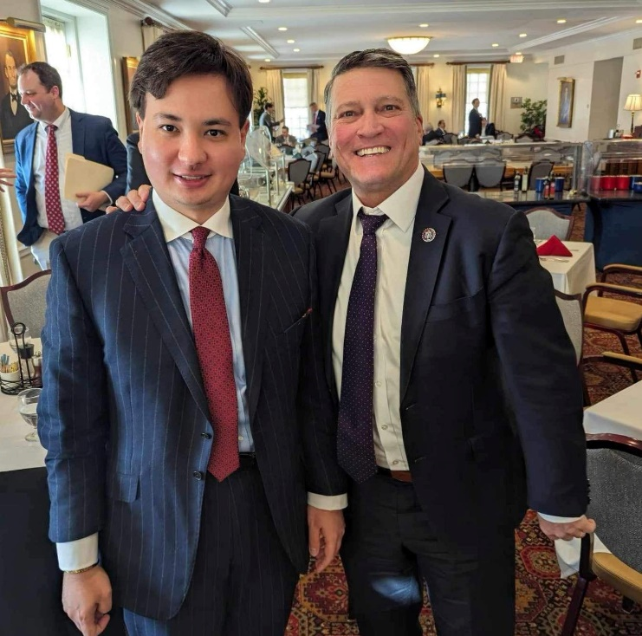

(L-R) GHA Executive Director & Congressman Ronny Jackson

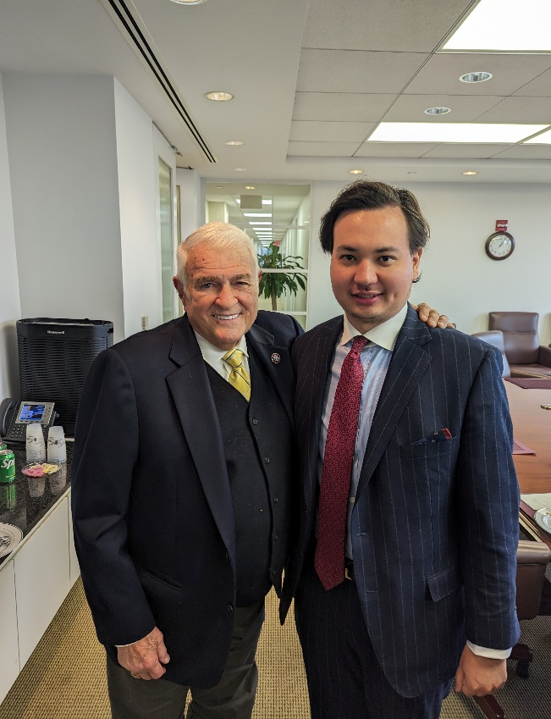

(L-R) GHA Executive Director & Congressman John Carter

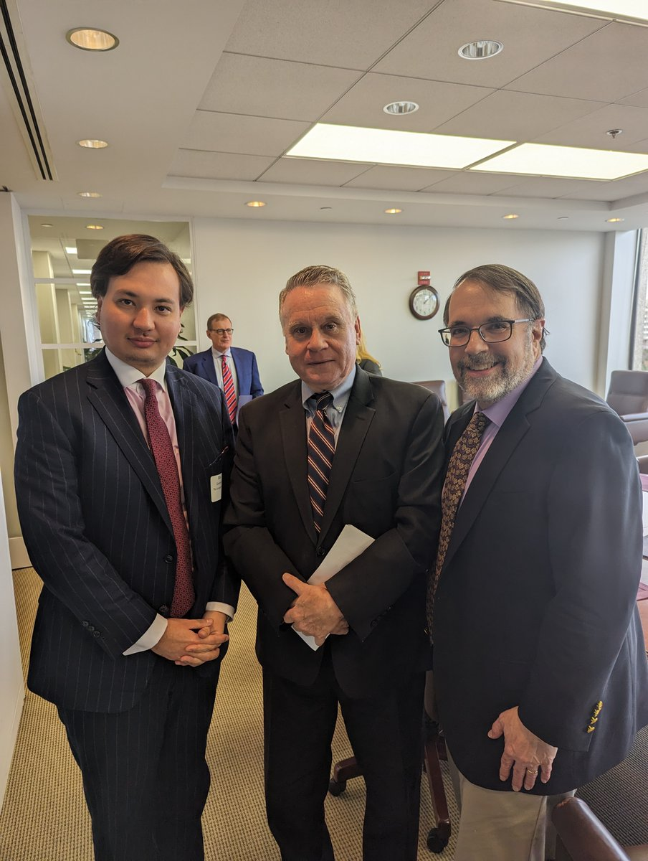

(L-R) GHA Executive Director, Congressman Chris Smith, & GHA Board Member Peter Tompa

**About Global Heritage Alliance**

Global Heritage Alliance is a Washington, DC-based advocacy organization, led by well-respected figures from the art, antiquities, and political worlds.

GHA calls for a balanced U.S. government approach to cultural policy based on American values. Global and international access to art are in the public interest. U.S. cultural life is enhanced by the lawful international exchange of art and antiquities; of which museums, scholars, private collectors, dealers, and auction houses play an instrumental role.

GHA advocates for recognition of religious and cultural rights in U.S. foreign policy. We support the protection of private property of American citizens, businesses and museums as well as that of religious and ethnic minorities across the globe. We make clear the facts necessary to good U.S. policy on the arts and the harms of foreign government confiscation by lawless and rogue regimes. Working together with religious and ethnic minorities and public interest organizations, we educate legislators, government agencies and the U.S. public.